**DAILY ONLINE ACTIVITIES SUMMARY**

|  |  |  |  |  |  |  |  |  |
| --- | --- | --- | --- | --- | --- | --- | --- | --- |
| **Date:** | **16/07/2020** | | | | | **Name:** | **Katira Krishna J** | |
| **Sem & Sec** | **8th A** | | | | | **USN:** | **4AL16CS045** | |
| **Online Test Summary** | | | | | | | | |
| **Subject** | | **-** | | | | | | |
| **Max. Marks** | | **-** | | **Score** | | | **-** | |
| **Certification Course Summary** | | | | | | | | |
| **Course** | **Data Science Tools** | | | | | | | |
| **Certificate Provider** | | | **Cognitiveclass.ai** | | **Duration** | | | **5 hours** |
| **Coding Challenges** | | | | | | | | |
| **Problem Statement: Python program to implement binary search with recursion** | | | | | | | | |
| **Status: Completed** | | | | | | | | |
| **Uploaded the report in Github** | | | | | **Yes** | | | |
| **If yes Repository name** | | | | | **Krishna_Katira** | | | |
| **Uploaded the report in slack** | | | | | **Yes** | | | |

Online Test Details:

No test conducted

Certification Course Details:

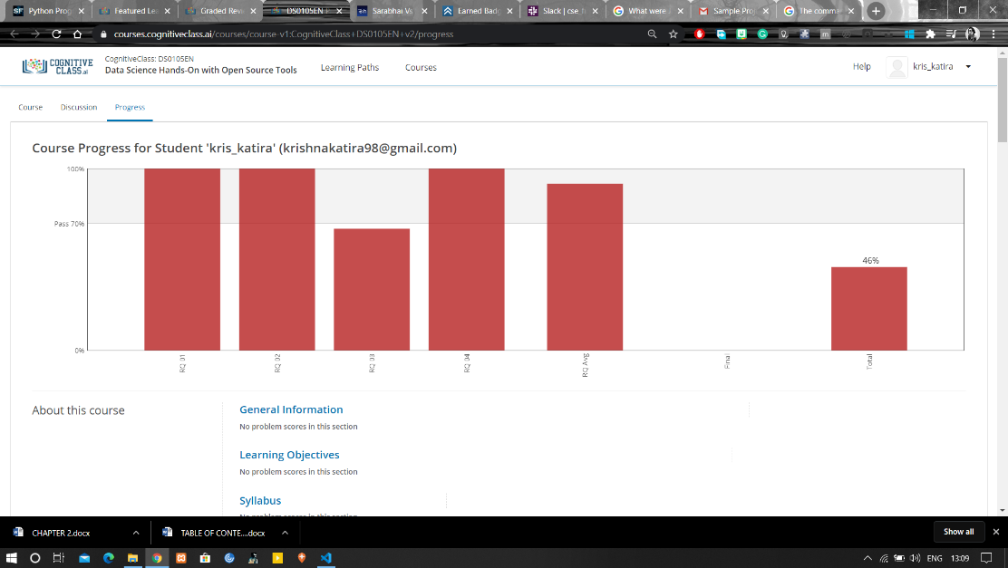

Coding Challenges Details:

**Program:**

def binary_search(alist, start, end, key):

"""Search key in alist[start... end - 1]."""

if not start < end:

return -1

mid = (start + end)//2

if alist[mid] < key:

return binary_search(alist, mid + 1, end, key)

elif alist[mid] > key:

return binary_search(alist, start, mid, key)

else:

return mid

alist = input('Enter the sorted list of numbers: ')

alist = alist.split()

alist = [int(x) for x in alist]

key = int(input('The number to search for: '))

index = binary_search(alist, 0, len(alist), key)

if index < 0:

print('{} was not found.'.format(key))

else:

print('{} was found at index {}.'.format(key, index))